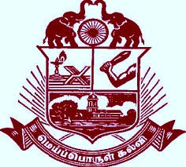

Government Arts College

(Autonomous)

Re-accredited (II Cycle) with ‘A’ Grade by NAAC

Affiliate to Bharathidasan University

Kumbakonam-612 002, Tamilnadu :2442149



**IDENTITY CARD**

**Blood Group** **D. O. B:**

A1+ve **19.05.2006**

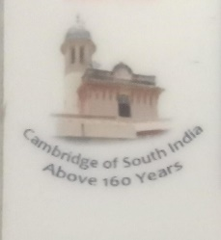

**KISHORE. R**

**B.Sc., Computer science**

**E 23 CS 4798**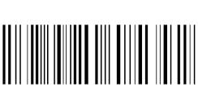

Father’s Name: N. Ramalingam

12, A, Elanga Nagar,

Kumbakonam – 612 001.